

**Energy Profile**

Giridih Secondary Steel

Cluster

**May 2024**

**Contents**

Abbreviations

Overview of the cluster 1

Product, market and production capacities 1

Production process of selected industries 3

Energy consumption in cluster 4

Technologies employed. 5

Potential energy efficient technologies 6

Decarbonisation of the cluster 8

SWOT Analysis 9

Socio-economic dimension 10

Abbreviations

|  |  |
| --- | --- |
| BF | Blast Furnace |
| BOF | Basic Oxygen Furnace |
| CCM | Continuous Casting Machine |
| CO2 | Carbon dioxide |
| DIC | District Industries Centre |
| DRI | Direct Reduced Iron |
| DVC | Damodar Valley Corporation |
| EIF | Electric Induction Furnace |
| EAF | Electric Arc Furnace |
| Fe | Iron |
| FO | Furnace Oil |
| GHG | Greenhouse gas |
| IE3 | Premium efficiency |
| IE4 | Super premium efficiency |
| IGBT | Insulated gate bipolar transistor |
| JBVNL | Jharkhand Bijli Vitran Nigam Limited |
| MSME | Micro Small and Medium Enterprise |
| MS | Mild Steel |
| Mt | Million Tonnes |
| MU | Million Units (kWh) |
| NH | National Highway |
| PLC | Programmable Logic Controller |
| SAF | Submerged Arc Furnace |
| SCR | Silicon-controlled rectifier |
| SEC | Specific Energy Consumption |
| SMS | Steel Melting Shop |
| SRRM | Steel re-rolling mill |
| TERI | The Energy and Resources Institute |
| TMT | Thermo Mechanically Treated |
| TPA | Tonnes per annum |
| TPD | Tonnes per day |
| Toe | Tonnes of oil equivalent |
| UHP | Ultra high power |
| VFD | Variable Frequency Drives |
| WHR | Waste heat recovery |
| WI | Wire Industries |

Overview of the cluster

Giridih, a district of Jharkhand state, was carved out from Hazaribagh district in 1972. Lying in the central part of the Chhota Nagpur plateau, it is bounded by Jamui and Nawada districts of Bihar in the north, Deoghar and Jamtara in the east, Dhanbad and Bokaro on the south and by Hazaribag and Koderma on the west. The district is rich in mica and coal. The region has historically been associated with mining activities. In early phases of industrialisation, the district had several mica-based industries. The steel industries started evolving in the area about two decades back. The district is well connected by road, rail, and electricity grid. The famous Grand Trunk Road (NH-2) passes through this district. Electricity is supplied by Damodar Valley Corporation (DVC) and Jharkhand Bijli Vitran Nigam Limited (JBVNL). Most of the industries use DVC power supply due to reliability of supply and cheaper tariff rate.

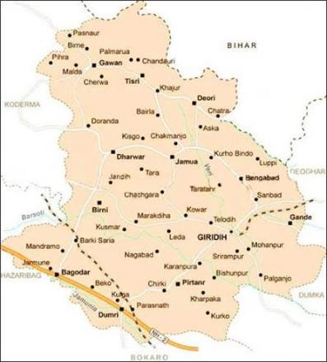

Figure 1: Giridih map (source: google images)

Product, market and production capacities

There are about 30 steel-based industries in the cluster. Most of the industries are situated in Tundi road and surrounding areas. Category of steel industries in the region includes pig iron, sponge iron/ direct reduced iron (DRI), ferro alloys, steel re-rolling mill (SRRM) and wire industry (WI) (Figure 2). Major products produced are billets, wires, bars, rods, nails and so on. The cluster is one of the major producers of TMT bars of Fe 550 and Fe 600 grade. The products are catering to the local, domestic, and international market.

These industries use a range of technologies in the production process. The different types of technology, raw material and energy used in Giridih steel industries is provided in Table 1.

Figure 2: Type of industries in the cluster

Table : Technology, energy and raw material use in Giridih steel industries.

|  |  |  |  |  |
| --- | --- | --- | --- | --- |
| Technology | User industry | Raw material | Energy used | Product |
| Rotary kiln | DRI/ Sponge iron | Iron ore, dolomite | Coal, electricity | DRI/Sponge iron |
| Submerged arc furnace (SAF) | Ferro alloys | Mineral ore | Coke, electricity | Ferrosilicon, silico manganese |
| Blast furnace (BF) | Pig Iron | Iron ore | Coke | Pig Iron |
| Electric induction furnace (EIF) | Steel Melting Shop (SMS) | Sponge iron, Pig iron, scrap | Electricity | Ingots and billets |
| Re-heating furnace | SRRM | Ingots and billets | Coal | Heated ingots and billets |
| Continuous casting machine (CCM) | SRRM | Liquid metal | Electricity | Billets |
| Rolling mill | SRRM | Hot ingots and billets | Electricity | TMT bars, angles, channels, strips |
| Wire drawing machine | Wire industry | Wire Rods | Electricity | Barbed wire, iron binding wire, nails |

Few of the industries in the cluster are integrated i.e. they make the final product from the iron ore and have all the downstream technologies and produce the finished product. A profile of the industries in the cluster is presented in Table 2. Share of production by type of industries is given in Figure 3.

Table : Profile of industries

Figure 3: Share of steel production industry-wise

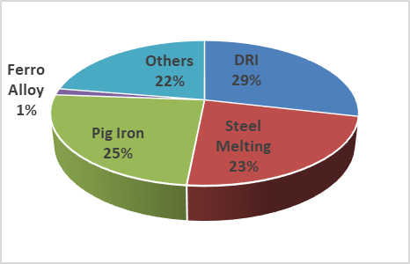

|  |  |  |
| --- | --- | --- |
| Type | Nos | Production (TPA) |
| DRI | 6 | 7,50,000 |
| Steel Melting | 8 | 6,00,000 |
| Pig Iron | 3 | 6,45,000 |
| Ferro Alloy | 1 | 37,400 |
| Others | 23 | 5,86,800 |
| Total | 41 | 26,19,200 |

The overall steel production in the cluster is estimated to 2.61 million tonnes (Mt).

Production process of selected industries

1. Sponge iron

DRI, commonly known as sponge iron, is produced through coal-based route in cluster. The raw materials are fed into a rotary kiln. On completion of metallization through reduction process, the mixture of sponge iron and residual charge are transferred to a rotary cooler through a belt conveyor. The solid discharge is passed through an electromagnetic separator to separate sponge iron and char. A typical process flow of sponge iron production is shown in Figure 4.

Figure 4: Sponge iron process flow

1. Ferro alloys

Ferro alloys are produced through smelting process which involves high temperature melting of the raw materials in a submerged arc furnace. Ferro alloy products such as ferromanganese and silicomanganese is produced in the cluster. Stroking is done through the electrodes in the submerged arc furnace. The molten ferro alloy is drawn out from bottom of the furnace through tapping holes at a temperature of 1500-1600℃. The process flow is shown in the Figure 5.

Figure 5: Ferro alloy process flow

1. Steel melting shop

Induction furnace melting units are commonly called steel melting shops. Raw materials like pig iron, metal scrap and sponge iron are melted in induction furnaces. The molten metal is transferred to casting machine through ladle. In many units, the metal is poured in continuous casting machine and billets are produced which are further re-rolled into long products.

1. Re-rolling

In the rerolling units the raw material, billet is charged into the reheating furnace for heating. The billets are heated to temperature of 1100-1200℃ to deform its shape further in the rerolling mills.

The hot billet is passed through the rollers several times to attain the desired shape. The final product shape can be in the form of round bar, flat, angle or channels depending on the type of products. Mostly TMT (thermo mechanically treated) bars are produced in the rerolling units. Typical process flow of re-rolling units is shown in Figure 6.

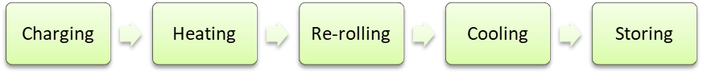

Figure 6: Process flow of rerolling units in the cluster

1. Wire drawing

Industries in the cluster are also manufacturing different types of wires which are used in construction and civil work. The type of wire produced in the cluster include steel wire, barbed wire, iron binding wire, galvanised wire etc. The wire rod coil is straightened first and drawn through wire drawing machine. It is further processed to improve its tensile strength, binding quality though intermediate process like annealing and galvanising. Finally, the drawn wire is coated to remain rust free and coiled in bundles to dispatch to customers.

Energy consumption in cluster

Coal/coke and electricity are the major sources of energy in the iron and steel industries. Coal is used in production of pig iron, sponge iron, ferro alloys and to operate reheating furnace. Electricity is used to operate the submerged arc furnace and induction furnace along with all the other auxiliary equipment in the plant. The energy consumption profile of the cluster is shown in Table 3.

Table : Energy consumption in cluster

| Type of  industry | Energy consumption | | Total | |
| --- | --- | --- | --- | --- |
| Thermal (Coal) | Electricity | Energy consumption | GHG emission |
| Mt/year | MU/year | toe/year | Mt CO2/year |
| DRI | 1.05 | 90 | 5,32,740 | 1.97 |
| Steel melting | - | 720 | 61,920 | 0.51 |
| Pig iron | 0.39 | 65 | 2,37,747 | 1.17 |
| Ferro alloys | 0.03 | 180 | 32,269 | 0.21 |
| Others | 0.02 | 41 | 13,783 | 0.07 |
| Total | **1.49** | **1095** | **8,78,459** | **3.93** |

Total energy consumption in the cluster is calculated to 0.87 Mtoe per year. Of the total energy consumption, thermal energy accounts for 89% while electricity accounts for 11%. The share of energy consumption by the type of industry in the cluster is shown in Figure 7 and share of energy consumption by fuel type is shown in Figure 8. Emissions from the fuel consumed in the cluster is estimated to be 3.93 Mt of CO2.

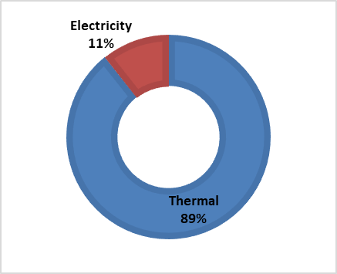

Figure 8: Share of energy consumption by fuel type

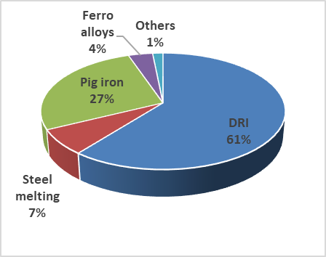

Figure 7: Share of energy consumption by type of industry

Technologies employed.

Some of the major equipment used in production of steel are described below.

1. Rotary Kiln

Rotary kiln is the heart of the coal-based reduction process for DRI production. The diameter and the length of the kiln depends on its capacity. It is usually inclined at 2.5° downward slope and rests on two to four support stations, depending on the kiln size. The transport rate of materials through kiln can be controlled by varying its slope and speed of rotation. There are inlet and outlet cones at opposite ends of the kiln which are cooled by its individual fans. The kiln shell is provided with small sampling ports. A typical rotary kiln is shown in Figure 9.

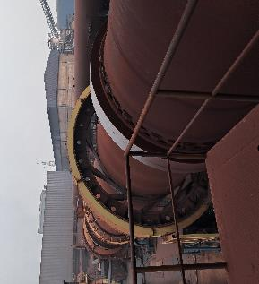

Figure 9: Rotary Kiln

1. Submerged arc furnace

Submerged arc furnace (SAF) is used in ferro alloy production. Energy required for producing the melt is provided by the electric arc between each of the three electrodes and metallic charge. The construction of SAF encompasses an outer cylindrical steel shell internally lined with several layers of refractory materials. The crucible and electrodes are water cooled to maintain the temperature and improve the service life.

1. Electric Induction furnace

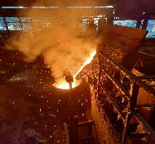

Figure 10: Induction furnace

Electric induction furnace (EIF) use silicon-controlled rectifier (SCR) or insulated gate bipolar transistor (IGBT) to melt the metal. This equipment is used in Steel melting shops for melting the metal. It is electrically operated and consumes significant amount of electricity in the melting process. A typical induction furnace is shown in Figure 10.

1. Blast furnace

A blast furnace is a vertical shaft furnace designed to produce pig iron. The furnace utilizes iron ore, limestone and coke as raw materials. The final products are molten metal and slag, tapped from the bottom, while waste gases exit from the furnace's top.

1. Reheating furnace

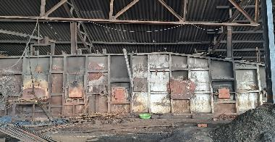

Figure 11: Reheating furnace

Reheating furnace is used in the rolling mills which do not have melt shops. These furnaces heat the billets to around 1100-1200℃ temperature. Reheating furnaces use coal as fuel. Reheating furnaces are equipped with recuperator systems to utilise the waste heat for preheating of combustion air. Reheating furnace with recuperator system is shown in Figure 11.

1. Wire drawing

Figure 12: Wire drawing

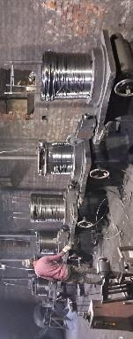

Wire drawing involves reducing the cross-sectional area of the wire by pulling it through a series of drawing dies. A typical wire drawing factory is shown in Figure 12.

Potential energy efficient technologies

Some of the energy efficient technologies of relevance to the cluster are discussed below.

1. Waste heat recovery (WHR) system for DRI

In a coal-based DRI using a rotary kiln, the off-gases exit the kiln at temperatures ranging between 950 to 1025°C. This heat can be utilised by employing a WHR boiler to produce high-pressure steam for power generation. A typical 2x100 tpd plant has potential to generate 4 MW of power. The power generated is used for self-consumption and excess can be exported to the grid.

1. Replacement of iron ore lumps with pellets

Coal-based DRI plants commonly utilize iron ore lumps sized between 5 to 20 mm. The mined iron ore typically contains a lot of fines, necessitating agglomeration processes. Use of iron ore pellets instead of lumps, can notably enhance the yield of the DRI process. This measure will enhance the production rate as well.

1. Improved kiln lining to reduce surface heat losses

In conventional rotary kiln, high-alumina low-cement castable refractories are used for inner lining. The temperatures of external surfaces of the kiln are about 180–250℃. The radiation heat loss of the rotary kiln typically accounts for about 5% of the total heat input, which can be reduced with application of low-thermal conductivity materials like micro-porous lining. Improved kiln lining can result saving of 5 kg/ton of coal.

1. Oxy fuel burner for arc furnace

In arc furnace, during operation, cold spots form between electrodes on the peripheral areas of furnace bottom. These cold spots within the furnace would lead to increase in tap-to-tap time thereby increasing the specific energy consumption. Oxy-fuel burners which use gaseous fuel to provide chemical energy to cold spots, thereby ensuring more uniform melting and homogeneity of temperature of the molten metal bath. The energy savings with use of oxy-fuel burners is about 3%.

1. High efficiency recuperator for reheating furnaces

Waste heat from high-temperature flue gases (650–800℃) in reheating furnaces can be recovered to reduce fuel consumption. A recuperator is used to preheat the combustion air. Recovering heat from the flue gases and transferring it to combustion air can reduce fuel consumption by up to 25%.

1. Excess air optimization and VFDs on combustion fans

Waste heat generation correlates with the amount of air used for combustion in reheating furnaces. Slight excess air, beyond stoichiometric ratios, ensures complete fuel combustion, dependent on fuel type. Excess air reduces combustion efficiency, generating excessive hot waste gases. Controlling oxygen levels and using VFDs aid in controlling oxygen levels, especially during varying production rates. Estimated energy savings range from 4-9% of thermal energy.

1. Improved insulation and refractories of reheating furnace

The heat loss from furnace walls and material discharge doors is about 3–5%, which is significant. Reduction in radiation heat loss from furnace surfaces can be achieved by enhancing the insulation. Covering of internal wall surface with ceramic fibre insulation and external wall surface with ceramic fibre or rock wool insulation will reduce the losses. The potential energy savings for insulating a reheating furnace were estimated to range from 2–5%.

1. Installation of CCM in place of reheating furnace.

Installing continuous casting machines (CCM) allows direct rolling of hot metal from induction furnaces without the need for reheating furnaces, significantly reducing coal consumption and energy costs. By eliminating the reheating step, energy consumption decreases, leading to reduced environmental impact and operational costs. The energy saving potential is estimated to be 400 kWh/tonne by adopting this technology.

1. Use of energy efficient electric motors

Electric motors are used for rolling in roughing, finishing mills and other auxiliary process in production of DRI, ferro alloy and induction furnace units. Use of energy efficient motors of premium efficiency (IE3) or super premium efficiency (IE4) motors would save 10% on the present electricity consumption.

1. Use of energy efficient pumps

By replacing the inefficient pumps with energy efficient pumps pose significant energy saving potential up to 25% on pumping electricity consumption.

Decarbonisation of the cluster

Regions undergoing industrial transition share a range of very specific, yet highly interconnected opportunities and challenges resulting from their legacy of manufacturing activity. These regions often possess strong capabilities and knowledge in important industries of today but need to re-orient these towards new and emerging activities for the industries of tomorrow. A key challenge for successful industrial transition is boosting the ability of regions and their industries to break out of locked-in paths of development by pursuing innovation, new technological pathways and industrial renewal.

1. Readiness of cluster

The readiness of the cluster for energy transition is significantly hindered by a lack of basic infrastructure, such as roads and railways, which complicates material transport and overall business operations. Entrepreneurs in the region struggle due to limited access to information on new technologies, energy-efficient practices, and lack of government support schemes. Despite producing a reasonable amount of goods, the lack of adequate facilities and support services puts the region at a disadvantage. The prevalent mindset among industry workers, who see coal as indispensable, coupled with the absence of stringent regulations, further stalls the transition. Additionally, entrepreneurs are concerned about the financial burden of transitioning in a competitive market, where large players often overpower smaller industries. To enable an effective transition, substantial support from the government and local administration, including robust infrastructure development and clear regulatory frameworks, is crucial.

1. Cost of decarbonization

The cost of transitioning the steel cluster to adopt low-carbon technologies varies based on operational scale, technological progress, and regulatory standards. In the Giridih cluster, which significantly contributes to Jharkhand's economy, residents will experience several changes during this transition. The cluster currently produces 0.75 Mt of DRI. Implementing low-carbon practices like producing DRI through hydrogen-based route would require approximately 45,000 tonnes of hydrogen per year. If this hydrogen is sourced from renewable energy, it would require around 2.17 GW of solar photovoltaic (PV) installation. The cost for producing 45,000 tonnes of green hydrogen per year green hydrogen based is estimated at $1.450 billon USD. This cost includes the costs of solar PV plant and electrolysers . OtherCosts such as the capex for installing gas based DRI plants, infrastructure costs forhydrogen storage and transportation DM water cost, land and so on will be additional.

If the present electricity consumption of the cluster (1,095 million kWh) is entirely produced by renewable energy, installation of , , 730 MW of solar PV capacity would be required. The capex requirement for the solar PV would be about USD 440 million. This is exclusive of the battery storage system, which would be necessary for 24x7 solar power supply.

SWOT Analysis

A SWOT (Strength, Weakness, Opportunity, and Threat) analysis of the iron and steel industry in Giridih cluster was conducted. The SWOT analysis is summarised in table below.

|  |  |
| --- | --- |
| **Strengths**   * Availability of raw materials * Well connected by road and rail network * Cheap manpower availability * Cheap land availability | **Weakness**   * Lack of access to knowledge and skills regarding new technologies * Lack of strong support institutions at local level * Degrading water and land quality due to pollution * Higher cost of logistics Lack of incentives for upgradation |
| **Opportunities**   * Increasing domestic demand for steel products * Few cluster development initiatives have been undertaken * Capacity expansion provides an opportunity to adopt new technologies * Increase scale of production | **Threats**   * Increasing cost of environmental compliance * Large number of SME players * Few large players may dominate the market * Closure of units if not met by pollution compliance * Non-availability of skilled manpower * Low vision on future needs and business opportunities |

Socio-economic dimension

The socio-economic aspects of the cluster was analysed to gain insight into the living conditions and economic status of the steel industry workforce. Giridih remains underdeveloped compared to many other regions in the country. The region's economy is predominantly driven by coal mining and associated transportation activities. Despite regulatory constraints, illegal coal mining persists as a significant livelihood option for many.

The industrial workforce comes from nearby areas and neighbouring states. Labour contractors are responsible for hiring workers, managing their attendance, overseeing their activities, and handling aspects of their employment such as salary, health, and safety. The contract system leads to delays in payment of wages and lesser earnings for workers', as contractors exert considerable control over their employment terms. Contractual workers lack access to basic benefits like Employee State Insurance (ESI)/medical insurance and Provident Funds (PF)/social security.

The ratio of permanent employees to contract labour is low. Permanent staff members are generally engaged in supervisory or managerial roles, while contract labourers handle core production tasks such as material handling and un-skilled jobs The unskilled workers receive on-the-job training and lack opportunities to undergo formal skilling programs. Industries are reluctant to invest in training due to perceived disruption in production and a focus on profit maximization.The working conditions within these industries are poor, with minimal health and safety protection. Essential safety equipment such as heat-resistant clothing, gloves, goggles, earplugs, and safety shoes are not provided/used endangering the health and safety of the workers. There is lack of emergency and critical healthcare services for SME workers.

Awareness and utilization of government schemes are limited among the workers, due to a lack of knowledge and/or cumbersome processes required to access these benefits. Environmental pollution has significantly impacted the region's quality of life, deteriorated water and soil quality and severely reduced soil fertility especially in surrounding areas. Other economic opportunities are scarce, compelling workers to endure harsh working conditions.

Despite these challenges, workers remain attached to the place, finding relocation inconvenient and holding onto the hope that conditions will eventually improve for their next generation. Substantial and sustained efforts in terms of policies and investment are needed to enhance the economic growth of the region and transform it into a more vibrant industrial hub in terms of opportunities for the local population.